**Problem 3 - Bakery Shop**

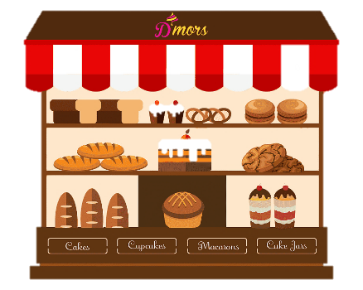

*Maria is opening a bakery shop, and she needs your help to keep track of the stock availability.*

Create a program that keeps the information about the stock at the shop.

You will be receiving **lines** with commands until you receive the **"Complete"** command. The **possible** commands are:

* **"Receive {quantity} {food}":**
  + Add the **quantity** to the given **food**.
  + If the food **does not** exist, **add** it to your record.
  + If the **quantity is invalid** (<= 0), ignore the command.
* **"Sell {quantity} {food}":**
  + If the **food** is **not in your record**, print: **"You do not have any {food}."**.
  + If there is **not enough quantity** of the wanted food, you should sell (decrease) **what you** **have in stock** and then remove **the food** from your record. Print: **"There aren't enough {food}. You sold the last {sold quantity} of them."**
  + Otherwise, **decrease** the **quantity** of the given **food** and print: **"You sold {quantity} {food}."**.If, **after reducing the quantity**, there is **0 amount of this food**, you should **remove it** from your record.

**You must keep track of all sold food quantities!**

In the end, you should **print the stock availability** in the format:

**"{food1}: {quantity}**

**{food2}: {quantity}**

**…**

**{foodN}: {quantity}**

**All sold: {count of all sold food quantity} goods"**

**Input**

* You will be receiving linesuntil you receive the **"Complete"** command.
* The input will **always** be **valid**.

## Output

* **Print** the **stock availability** in the **format** described above.
* **Print** the amount of **all sold food** in the **format** described above.

## Examples

## JS Examples

|  |  |
| --- | --- |
| **Input** | **Output** |
| ([Receive 105 cookies,  Receive 10 donuts,  Sell 10 donuts,  Sell 1 bread,  Complete]) | You sold 10 donuts.  You do not have any bread.  cookies: 105  All sold: 10 goods |
| ([Receive 10 muffins,  Receive 23 bagels,  Sell 5 muffins,  Sell 10 bagels,  Complete]) | You sold 5 muffins.  You sold 10 bagels.  muffins: 5  bagels: 13  All sold: 15 goods |